**Chbe 4400 Project 1**

Group 1

Jiyuan Ding

Junxian Wu

Zongzhe Xue

1. Balances

Mass Balance:

$$V_{t}\frac{{dC}_{2}}{dt}=input-output-con+gen$$

$V_{t}ρ\frac{{dC}_{2}}{dt}=F_{1}ρC_{1}-C_{vp}\sqrt{ρgh}ρC_{2}-k_{0}e^{-\frac{E_{a}}{{RT}_{2}}}V_{t}ρC_{2}$ (1)

Linearization for later use:

$$V_{t}=Ah$$

$$\frac{{dC}_{2}}{dt}=\frac{F_{1}C_{1}}{Ah}-\frac{C_{vp}\sqrt{ρg}C_{2}}{A\sqrt{h}}-k_{0}e^{-\frac{E_{a}}{{RT}_{2}}}C_{2}$$

$$\frac{{dC}_{2}}{dt}=\frac{F_{1ss}C_{1ss}}{Ah_{ss}}+{\frac{F_{1ss}}{Ah_{ss}}(C_{1}-C}_{1ss})+\frac{C_{1ss}}{Ah_{ss}}\left(F_{1}-F_{1ss}\right)-\frac{F_{1ss}C_{1ss}}{Ah_{ss}^{2}}(h-h_{ss})$$

$$-C_{vp}\sqrt{ρg}(\frac{C_{2ss}}{\sqrt{h_{ss}}}-\frac{1}{2h_{ss}^{\frac{3}{2}}}C_{2ss}(h-h_{ss})+\frac{C_{2}-C_{2ss}}{\sqrt{h_{ss}}})$$

$$-k_{0}{(e}^{-\frac{E_{a}}{{RT}_{2ss}}}C_{2ss}-\frac{E_{a}}{RT_{2ss}}e^{-\frac{E_{a}}{RT_{2SS}}}c_{2SS}\left(T_{2}-T_{2SS}\right)+e^{-\frac{E_{a}}{RT_{2SS}}}\left(C_{2}-C_{2SS}\right))$$

Subtract steady state:

$$\frac{{dC}_{2}}{dt}=\frac{F_{1ss}}{Ah_{ss}}C_{1}^{'}+\frac{C_{1ss}}{Ah_{ss}}F_{1}^{'}-\frac{F_{1ss}C_{1ss}}{Ah_{ss}^{2}}h'$$

$$-C_{vp}\sqrt{ρg}(-\frac{1}{2h_{ss}^{\frac{3}{2}}}C_{2ss}h'+\frac{C_{2}^{'}}{\sqrt{h_{ss}}})$$

$$-k_{0}(-\frac{E_{a}}{RT_{2ss}}e^{-\frac{E_{a}}{RT_{2SS}}}c_{2SS}T_{2}^{'}+e^{-\frac{E_{a}}{RT_{2SS}}}C_{2}^{'})$$

(2)

If Steady State:

Since outflow mass must equal to inflow mass, we have:

$$F_{1}=F_{2}$$

$$0=C_{1}-C_{2}-\frac{k_{0}e^{-\frac{E_{a}}{{RT}_{2}}}V_{t}C_{2}}{F_{1}}$$

Energy balance:

$$ρV_{t}C_{p}\frac{{dT}_{2}}{dt}=input-output-remove+generate$$

$ρV_{t}C_{p}\frac{{dT}_{2}}{dt}=F_{1}ρC_{p}T_{1}-C_{vp}\sqrt{ρgh}ρC_{p}T_{2}-UA\left(T_{c}-T_{2}\right)+{ΔH}_{rxn}k_{0}e^{-\frac{E_{a}}{{RT}_{2}}}V_{t}ρC_{2}$ (3)

Linearization:

$$\frac{{dT}_{2}}{dt}=\frac{F_{1}T_{1}}{Ah}-\frac{C_{vp}\sqrt{ρg}T_{2}}{A\sqrt{h}}-\frac{UA}{ρC_{p}A}\left(\frac{T_{c}}{h}-\frac{T_{2}}{h}\right)+\frac{{ΔH}_{rxn}}{C_{p}}k_{0}e^{-\frac{E_{a}}{{RT}_{2}}}C_{2}$$

$$\frac{{dT}_{2}}{dt}=\frac{F_{1ss}T_{1ss}}{{Ah}_{ss}}+\frac{F_{1SS}}{{Ah}_{ss}}\left(T_{1}-T_{1SS}\right)+\frac{T_{1SS}}{Ah_{ss}}\left(F_{1}-F_{1SS}\right)-\frac{T_{1ss}F_{1ss}}{Ah_{ss}^{2}}\left(h-h_{ss}\right)$$

$$-C_{vp}\sqrt{ρg}(\frac{T_{2ss}}{\sqrt{h_{ss}}}-\frac{1}{2h_{ss}^{\frac{3}{2}}}T_{2ss}(h-h_{ss})+\frac{1}{\sqrt{h_{ss}}}(T_{2}-T_{2ss}))$$

$$-\frac{UA}{ρC_{p}A}\left(\frac{T_{css}}{h_{ss}}+\frac{T_{c}-T_{css}}{h_{ss}}-\frac{T_{css}}{h_{ss}^{2}}\left(h-h_{ss}\right)\right)+\frac{UA}{ρC_{p}A}\left(\frac{T_{2ss}}{h_{ss}}+\frac{T_{2}-T_{2ss}}{h_{ss}}-\frac{T_{2ss}}{h_{ss}^{2}}\left(h-h_{ss}\right)\right)$$

$$+\frac{{ΔH}_{rxn}}{C_{p}}k_{0}(e^{-\frac{E_{a}}{{RT}_{2ss}}}C_{2ss}-\frac{E_{a}}{RT_{2ss}}e^{-\frac{E_{a}}{RT_{2SS}}}c_{2SS}\left(T_{2}-T_{2SS}\right)+e^{-\frac{E_{a}}{RT_{2SS}}}\left(C_{2}-C_{2SS}\right))$$

At steady state:

$$0=\frac{F_{1ss}T_{1ss}}{{Ah}_{ss}}+0+0-0$$

$$-C_{vp}\sqrt{ρg}(\frac{T_{2ss}}{\sqrt{h_{ss}}}-0+0)$$

$$-\frac{UA}{ρC_{p}A}\left(\frac{T_{css}}{h_{ss}}+0-0\right)+\frac{UA}{ρC_{p}A}\left(\frac{T_{2ss}}{h_{ss}}+0-0\right)$$

$$+\frac{{ΔH}_{rxn}}{C_{p}}k_{0}(e^{-\frac{E_{a}}{{RT}_{2ss}}}C_{2ss}-0+0)$$

Finally:

$$\frac{{dT}_{2}}{dt}=\frac{F_{1SS}}{{Ah}_{ss}}T_{1}^{'}+\frac{T_{1SS}}{Ah_{ss}}F_{1}^{'}-\frac{T_{1ss}F_{1ss}}{Ah_{ss}^{2}}h'$$

$$-C_{vp}\sqrt{ρg}(-\frac{1}{2h_{ss}^{\frac{3}{2}}}T_{2ss}h'+\frac{1}{\sqrt{h_{ss}}}T_{2}^{'})$$

$$-\frac{UA}{ρC_{p}A}\left(\frac{T_{c}^{'}}{h_{ss}}-\frac{T_{css}}{h_{ss}^{2}}h^{'}\right)+\frac{UA}{ρC_{p}A}\left(\frac{T_{2}^{'}}{h_{ss}}-\frac{T_{2ss}}{h_{ss}^{2}}h'\right)$$

$$+\frac{{ΔH}_{rxn}}{C_{p}}k_{0}(-\frac{E_{a}}{RT_{2ss}}e^{-\frac{E_{a}}{RT_{2SS}}}c_{2SS}T_{2}^{'}+e^{-\frac{E_{a}}{RT_{2SS}}}C_{2}^{'})$$

(4)

Equation for h:

$\frac{dh}{dt}=\frac{F_{1}-C_{vp}\sqrt{ρgh}}{A}≈\frac{F_{1}-C_{vp}\sqrt{ρg}\left(\sqrt{h_{ss}}+\frac{1}{2\sqrt{h_{ss}}}(h-h_{ss})\right)}{A}$ (5)

At steady state:

(6)

2. Operating temperature plot:

$$Q_{reaction}={ΔH}_{rxn}k_{0}e^{-\frac{E_{a}}{{RT}_{2}}}V_{t}ρC_{2}$$

$$Q_{exchange}=-UA\left(T_{c}-T_{2}\right)$$

Use mass balance to substitute C2:

$C_{1}=C_{2}+\frac{k_{0}e^{-\frac{E_{a}}{{RT}_{2}}}V_{t}C_{2}}{F_{1}}$

$$C_{1}=C_{2}\left(1+\frac{k_{0}e^{-\frac{E_{a}}{{RT}_{2}}}V_{t}C_{2}}{F_{1}}\right)$$

$$C_{2}=\frac{C_{1}}{1+\frac{k_{0}e^{-\frac{E_{a}}{{RT}_{2}}}V_{t}C_{2}}{F_{1}}}$$

Plug C2 in the Qreaction:

$Q_{reaction}={ΔH}_{rxn}k_{0}e^{-\frac{E_{a}}{{RT}_{2}}}V_{t}ρ\frac{C_{1}}{1+\frac{k_{0}e^{-\frac{E_{a}}{{RT}_{2}}}V_{t}}{F_{1}}}$ (7)

$Q_{reaction}={ΔH}_{rxn}V_{t}ρ\frac{k_{0}C_{1}}{e^{\frac{E_{a}}{{RT}_{2}}}+\frac{k_{0}V_{t}}{F_{1}}}$ (8)

Evaluate eq (7) and (8) in Matlab, we get the following graph:

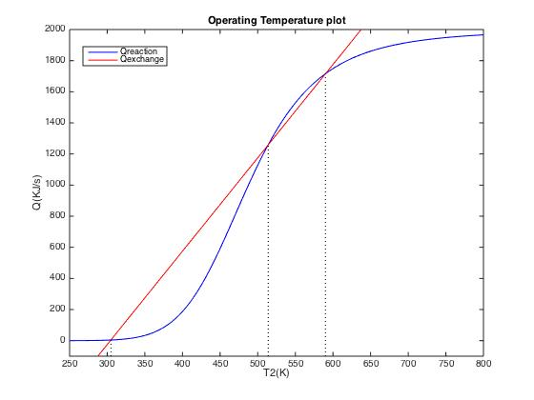

The highest operating temperature is about 590K. This system has three possible steady state operating temperature. However, only the left and right one are stable. If a disturbance causes the system to be a bit colder than the middle temperature, heat exchanger will remove more heat than the reaction can generate. This will cause the temperature to drop down to the left point. Likewise, the temperature will shift to the right if the system because a bit hotter than the middle point. The left and right points will always shift back to themselves whenever there’s a small disturbance.

3. Feed rate change response

By defining the nonlinear equations (1), (3) and (5) in Matlab and feeding them to an ode45 solver, the response of outlet concentration, temperature and liquid level was computed and represented in the following three images. Matlab code can be seen in appendix.

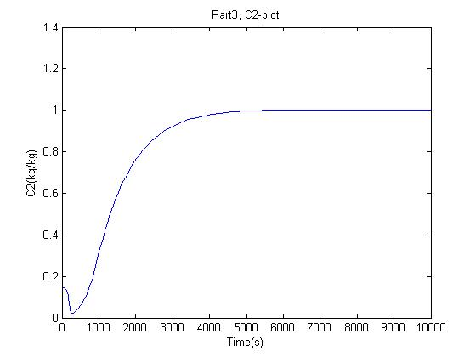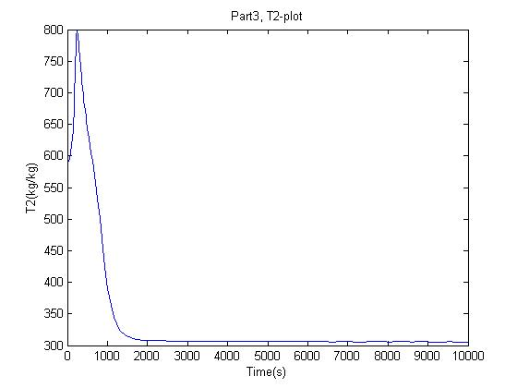

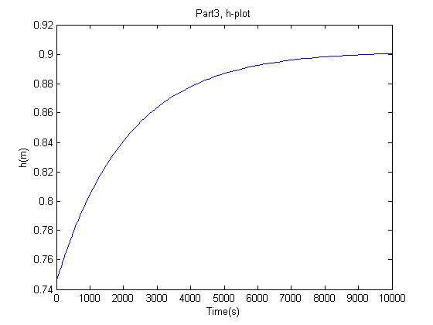

4. Feed temperature change response

Similarly, the outlet concentration and temperature response to a feed temperature change was computed and shown in the following two images.

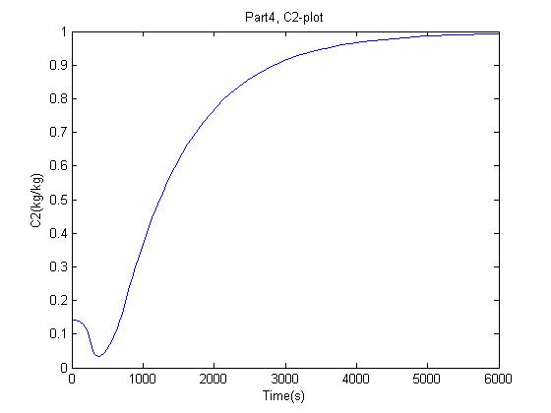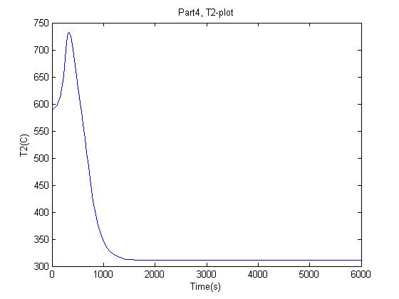

5. Cooling temperature change response

With the same method as part 3 and 4, the outlet concentration and temperature response are shown in the following two images.

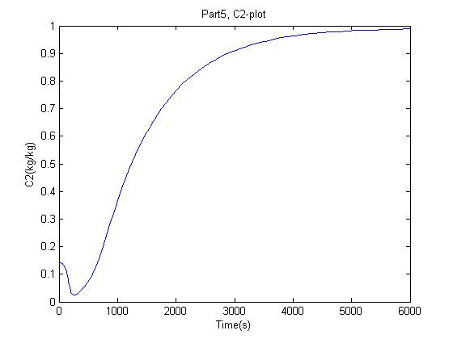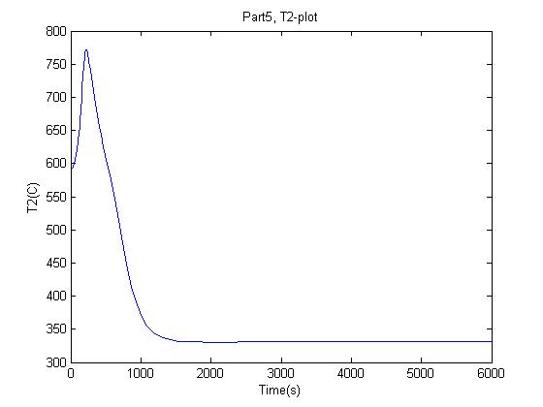

6. State space representation:

State variables: $\left[x\right]=\left[\begin{matrix}T_{2}^{'} \\ C_{2}^{'} \\ h^{'}\end{matrix}\right]$

Input variables: [u]=[$\begin{matrix}\begin{matrix}T_{1}^{'} \\ C_{1}^{'}\end{matrix} \\ \begin{matrix}F_{1}^{'} \\ T_{c}^{'}\end{matrix}\end{matrix}]$

Rearranging equation (2), (4) and (6), we get the following state-space representation:

= + [][]

7. Simulink

Compared to part 3:

$$\frac{T_{2}^{'}}{F_{1}^{'}}=(3.97e17*(5.76e17*s + 4.09e15))/(6.49e32*s^2 + 9.63e33*s + 9.69e30) - (1.56e21*(5.59e30*s + 8.39e28))/(5.99e51*s^3 + 8.88e52*s^2 + 1.34e50*s + 4.51e46) + 7.98e33/(6.49e32*s^2 + 9.63e33*s + 9.69e30)$$

$$\frac{C_{2}^{'}}{F_{1}^{'}}=(1.16e18*(5.63e14*s + 8.34e15))/(6.49e32*s^2 + 9.63e33*s + 9.69e30) - (2.34e20*(2.42e28*s + 6.35e29))/(5.99e51*s^3 + 8.88e52*s^2 + 1.34e50*s + 4.51e46) + 1.7e33/(6.49e32*s^2 + 9.63e33*s + 9.69e30)$$

$$\frac{h'}{F_{1}^{'}}= 6.93e18/(9.22e18*s + 4.65e15)$$

Compared to part 4:

$$\frac{T_{2}^{'}}{T_{1}^{'}}=(1.14e12*(5.76e17*s + 4.09e15))/(6.49e32*s^2 + 9.63e33*s + 9.69e30)$$

$$\frac{C_{2}^{'}}{T_{1}^{'}}=4.85e27/(6.49e32*s^2 + 9.63e33*s + 9.69e30)$$

Compared to part 5:

$$\frac{T_{2}^{'}}{T_{c}^{'}}=-(5.68e12*(5.76e17*s + 4.09e15))/(6.49e32*s^2 + 9.63e33*s + 9.69e30)$$

$$\frac{C_{2}^{'}}{T_{c}^{'}}=-2.43e28/(6.49e32*s^2 + 9.63e33*s + 9.69e30)$$